Helhoughton Parish Council
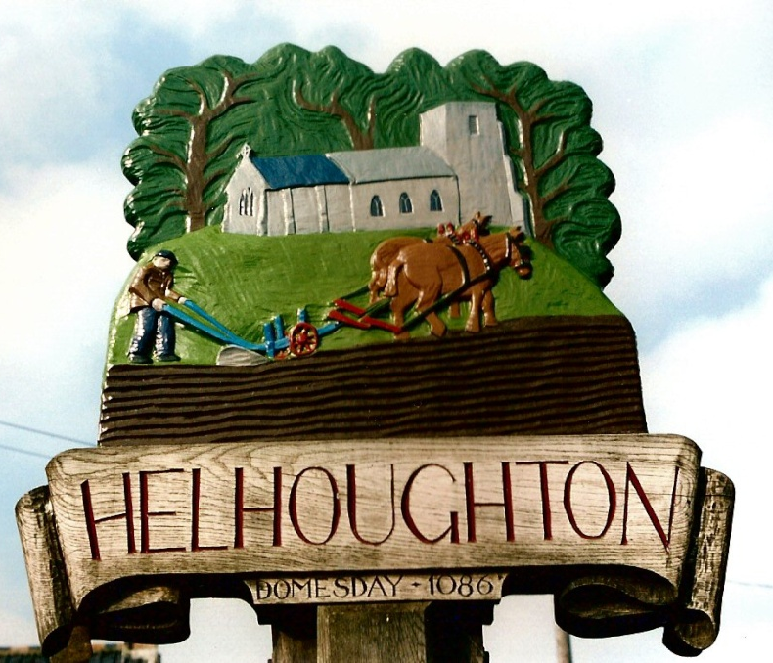
Annual Parish Meeting Minutes
Monday 18th May 2026 6.30pm

Parish Councillors present: Tim Harris (Chairman), Sean Millard (Vice Chair), Paul Flint, Melvin Lacey Freeman, Kit Price-Moss. Also in attendance: Sophie Bond (Parish Clerk), Maxine Hayes (Previous Parish Clerk), there were 8 members of the public present.

1. Welcome and introduction from the Chairman of the Council
Cllr Harris welcomed all those present and introduced the various community groups within the village.

2. To hear from the Village Hall Committee
Sean Millared has been elected as Chair. Following the hopes raised at the previous meeting, new curtains have now been obtained for the Hall. Usage of the Hall has also increased significantly, thanks to the success of several themed events, including the popular Pub Nights, the Thai Night funded by the Solar Fund, and the Harvest Lunch.
The committee’s aim is to continue increasing the Hall’s use within the community, while also exploring further improvements such as the introduction of Wi-Fi. Discussions are currently underway with Syderstone Village Hall with the hope of arranging a visit to gather inspiration and ideas for the future development of the Hall.
A special vote of thanks was given to Jean Freeman, in her absence, in recognition of her hard work, dedication, and continued support of the Village Hall over the past 35 years.

3. To hear from the Solar Committee

David Kettel, Chairman of the Solar Committee reported that the AGM was held on 5th May. While there has been no response yet regarding the grant, funds of at least £12,500 are expected in June. He noted that one application had been submitted.
Works at the Airman’s Arms have been delayed due to unexpected wiring issues, but it is hoped that the project will be up and running within the next couple of weeks.
Part of the committee’s budget has been used to support the church and funding was also provided for the Thai Night at the Village Hall. The committee is waiting for new applications to allocate funds.
Parishioners can view details of the grants that have been awarded and can also apply for a grant via the Parish Council website. Applications are open to everyone.

4. To hear from All Saints Church
Fr Clive Wylie and Fr Edward Gunn introduced themselves as the newly appointed Priest in charge and Assistant Curate for the Church on a three-year appointment. The Diocese are asking for £4,890 from Helhoughton to support the associated costs.
They explained that they are currently on a fact-finding mission and are feeling positive about the future. Work is currently underway to develop their website and they can also be found on Facebook and Instagram. Services are held at the Church on the third Sunday of every month at 10.30am.
At present, they are seeking an architect to assist with repair and restoration work. A special vote of thanks was also given to Jane Wisbey for her ongoing support.

5. To hear from the Friends of Helhoughton Playground
Members of the group reported that the swings in the playground have been repaired. However, a rope and log swing had been attached to the climbing frame and has since been removed.
Near the allotment side of the playground, several trees are falling down. The clerk will ask the grass-cutting team to remove them, and Cllr T. Harris will also contact the Estate Manager to discuss the matter further. Unfortunately, the teepee has been pulled apart. Smashed wine bottles were also found in the playground and have been removed. A safety inspection will be carried out in June.

6. To hear from Tim Harris with the Parish Council Chairman’s report
The Churchyard wall has been repaired and is looking good.
The Parish Council continues to work with the County Council regarding potholes and there has been a noticeable improvement.
The Council continues to take a neutral view regarding planning applications unless there is a clear positive or negative impact, in which case comments will be submitted.
Cllr T. Harris noted that the Parish Council now has a new website after losing access to the previous one. As the website is new, it is not yet appearing prominently in search results, but it is hoped that this will improve over time. Plans are underway to continue updating the site to make it more user-friendly and more widely used, with key information about the village, as well as Village Hall information and booking forms and links
The precept has been spent on grass-cutting, street lighting, administration, and legal obligations.
With regard to finances, the Parish Council currently holds £8,613.09 in its current account as at 31.03.26
Cllr Harris welcomed the new Parish Clerk, Sophie, and thanked everyone present for their efforts and support.

7. To approve the minutes of the meeting held on 20th May 2025
The minutes were approved without amendment and signed by the Chairman as a correct record.

8. AOB
Discussions were held regarding the Village Newsletter, including when and where it is published,
along with the possibility of also posting it on the Parish Council website.

The Chairman thanked everyone for attending and closed the meeting at 7.18pm.

Signed by Chairman: ................................................................... Date: ...........................................

